Tic-Tac-Toe Game Based on Q-Learning
Colab: https://colab.research.google.com/drive/1Ndcyc_K8SVBHR0E8U_GDU7vR6zitu6Og?usp=sharing
Youtube: https://youtu.be/YsPmEpLQ6Ck
Github: https://github.com/ryyyanw/CDS524_Individual_Assignment/tree/main

1 Introduction
This project applies the Q-learning algorithm, a fundamental reinforcement learning technique, to the design and implementation of a Tic-Tac-Toe game. The objective is to create an intelligent agent that learns optimal strategies through interaction with the environment, balancing exploration and exploitation to maximize cumulative rewards. Tic-Tac-Toe provides an ideal testbed for reinforcement learning because of its well-defined state space, finite action space, and clear winning conditions. This project mainly used Python and Numpy. Because this project was run on Colab, UI is accomplished using text symbols.

2 Game Design

2.1 Rules of the Game
The Tic-Tac-Toe game is played on a 3×3 grid where two players, one using X and the other O, take turns placing their marks. Player X always moves first, and the objective is to align three identical symbols in a row, column, or diagonal. If all nine cells are filled without either player achieving this condition, the game ends in a draw. Moves must be placed in empty cells, and any attempt to occupy an already filled position is invalid. These simple rules define the structure of the game and provide the foundation for reinforcement learning, as they establish the state space, action space, and clear winning and draw conditions for the agent to learn from.

2.2 Class Design of the Game
TicTacToeEnv class This class manages the overall environment and flow of the game. It initializes the board, provides available actions, and updates the game state when a move is made. It also includes logic for detecting wins and draws, making it the central component of the game environment.
QLearningAgent class This class is responsible for training and controlling the AI agent. It maintains the Q-table, selects actions using an epsilon-greedy strategy, and updates Q-values based on rewards. Through repeated training episodes, the agent learns an optimal policy to maximize long-term rewards.
print_board function This function handles the visualization of the board. It can display the current state of the game and, when needed, show index references to guide player input.
check_winner function This function determines whether a player has won by checking all possible winning combinations across rows, columns, and diagonals.
play_vs_ai function This function enables human players to compete against the trained AI. It manages player input, alternates turns between the human and AI, and displays the outcome of the game, whether win, loss, or draw.

2.3 UI Design
The user interface of this project is primarily expressed through Python’s built-in character output. Since the latest version of Python does not fully support Pygame, a character-based UI was chosen for convenience, allowing the game to run directly in Google Colab without additional dependencies. At the beginning of the game, an index reference is displayed so that players can understand which index corresponds to each cell on the 3×3 grid. Players then select their moves by entering the index of the desired position. When either the AI or the player wins, the game provides a clear message announcing the result.
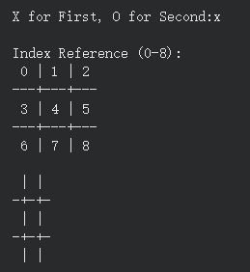
Fig 2.1 Tic-Tac-Toe UI-1
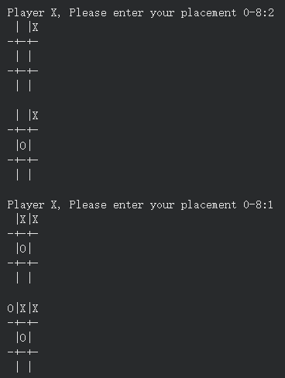
Fig 2.2 Gaming Process
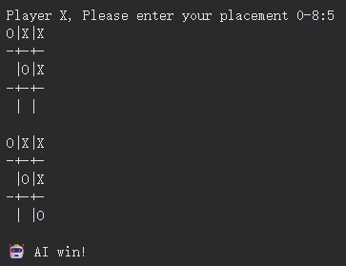
Fig 2.3 AI win the Game

3 Implement of Q-learning Algorithm
Q-learning is a value-based reinforcement learning algorithm that learns optimal actions by updating a Q-value table. In this project, the algorithm is applied to the discrete environment of Tic-Tac-Toe, where each action corresponds to placing a mark in one of the available cells. Since the game has a finite and well-defined state and action space, a Q-table is sufficient to represent the mapping between states and actions, without requiring a deep neural network.
The QLearningAgent class maintains the Q-table and implements three core functions. The get_q method retrieves the Q-value for a given state–action pair, defaulting to zero if the pair has not been encountered. The choose_action method selects actions using an ε-greedy strategy: with probability ε the agent explores by choosing a random move, and otherwise it exploits by selecting the action with the highest Q-value. The learn method updates the Q-table using the standard Q-learning update rule, where the new Q-value is a weighted combination of the old value and the target, defined as the immediate reward plus the discounted maximum Q-value of the next state.
Training is conducted over 50,000 episodes. At the start of each episode, the board is reset and the agent alternates between playing as X and O. The learning rate (α) is set to 0.1, the discount factor (γ) to 0.9, and the initial exploration rate (ε) to 0.2. These parameters ensure that the agent balances short-term rewards with long-term strategy. Over time, ε decays gradually, reducing exploration and allowing the agent to rely more on learned policies. Through this process, the agent learns to maximize cumulative rewards, converging toward strategies that increase its win rate against human players.

4 Challenges and Solutions
In this project, the reward function was modified in several ways. Since Tic-Tac-Toe is a game that very often ends in a draw, the AI’s opponent during training was designed to simply place its moves randomly. Initially, the reward function was defined only as +1 for a win, −1 for a loss, and +0.5 for a draw. However, this setup led to poor training results. The agent did not attempt to achieve faster victories but instead behaved almost like guessing, sequentially placing moves from the lowest index cell to the highest index cell without developing meaningful strategies.
To address the limitations of the initial reward design, the reward function in this project was refined with several improvements. Since Tic-Tac-Toe often ends in a draw and the opponent during training plays randomly, the original setup of simply assigning +1 for a win, −1 for a loss, and +0.5 for a draw did not encourage the agent to pursue faster or more strategic victories. Instead, the agent tended to behave mechanically, placing moves in order from the lowest index to the highest without developing meaningful tactics.
The current implementation introduces a more nuanced reward structure, as shown in the step function. Winning moves now yield the highest reward (+1.0), while draws return neutral rewards (0.0). To discourage unnecessarily long games, each move carries a small penalty (−0.05), encouraging the agent to seek quicker wins. Additional shaping rewards are included: occupying the center position grants a bonus (+0.2), and forming two-in-a-row opportunities provides incremental rewards (+0.3), with an even larger bonus (+0.5) if the move directly sets up a winning position. This refined reward function guides the agent toward more efficient and strategic play, significantly improving training outcomes compared to the initial design.
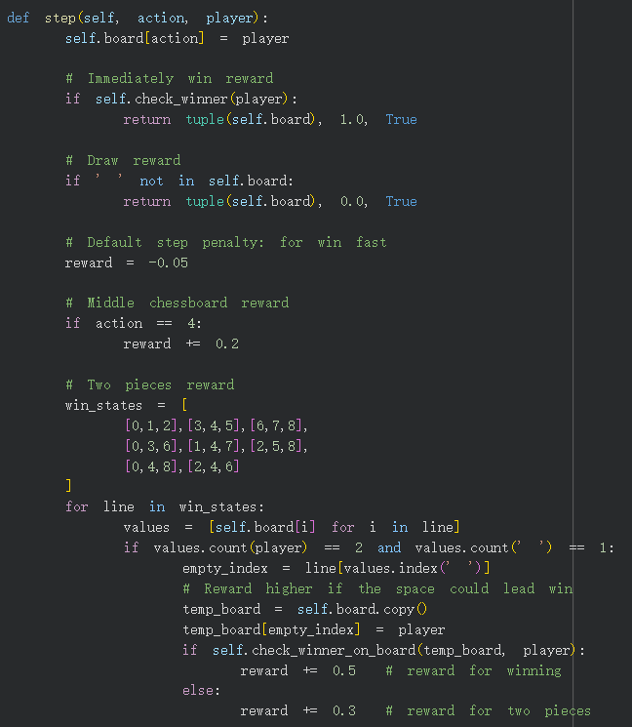
Fig 3.1 Reward function

In order to improve the effectiveness of training, the reward function in this project was refined with several enhancements. Since Tic-Tac-Toe often ends in a draw and the opponent plays randomly, the initial design of simply assigning +1 for a win, −1 for a loss, and +0.5 for a draw did not encourage the agent to pursue faster or more strategic victories. To address this, we introduced additional shaping rewards. A small step penalty was added to motivate the agent to finish games more quickly, while occupying the center position yields a bonus to reflect its strategic importance. Furthermore, the agent receives incremental rewards for creating two-in-a-row opportunities, with an even larger bonus if the move directly sets up a winning position.
This improved design significantly enhanced the agent’s learning process. Instead of mechanically filling cells in order, the agent began to prioritize advantageous positions and actively seek faster paths to victory. The refined reward function thus provided a stronger incentive structure, guiding the agent toward more intelligent and efficient strategies during training.

5 Conclusion
This project successfully demonstrates the application of the Q-learning algorithm to the classic game of Tic-Tac-Toe. By designing a clear environment with defined rules, states, and actions, and by implementing a Q-learning agent with an ε-greedy exploration strategy, the agent was able to learn effective policies through repeated training episodes. The use of Python and NumPy provided a simple yet powerful framework, while the text-based user interface ensured compatibility with Google Colab and allowed smooth interaction between human players and the AI.
A key challenge encountered was the initial reward function, which did not sufficiently encourage strategic play and led to poor training outcomes. Through iterative refinement, the reward function was enhanced with step penalties, center bonuses, and incremental rewards for two-in-a-row opportunities. These improvements significantly strengthened the agent’s learning process, enabling it to prioritize advantageous positions and pursue faster victories rather than relying on random or sequential moves.

6 Reference
[1] Wu, T., & Yu, C. (2022). Tic-tac-toe prediction based on machine learning methods. [2022 5th International Conference on Advanced Electronic Materials, Computers and Software Engineering (AEMCSE)]. IEEE.
https://ieeexplore.ieee.org/abstract/document/9948409
[2] te. (2025). Tetris-deep-Q-learning-pytorch [Computer software]. GitCode. https://gitcode.com/gh_mirrors/te/Tetris-deep-Q-learning-pytorch

